**Signing Up Into GitHub**

1. Navigate to <https://github.com/>.
2. Sign Up
3. Fill in the following Widget

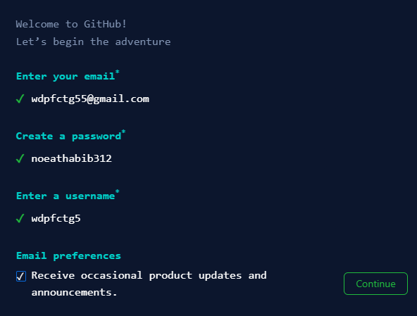

1. Click Continue
2. Nest Window:

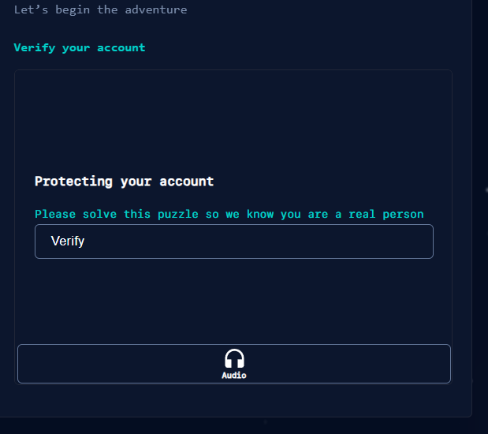

1. Click Verify
2. Next Widget

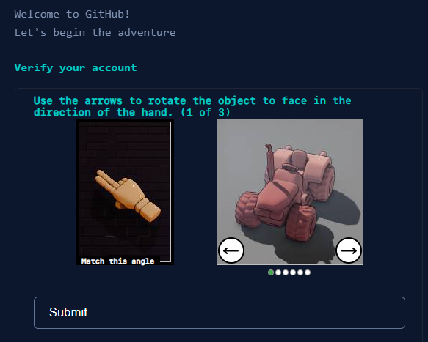

1. Follow the instructions and click Submit
2. A email will be sent to your gmail. Copy the Code and paste it in next Widget
3. Next Widget:

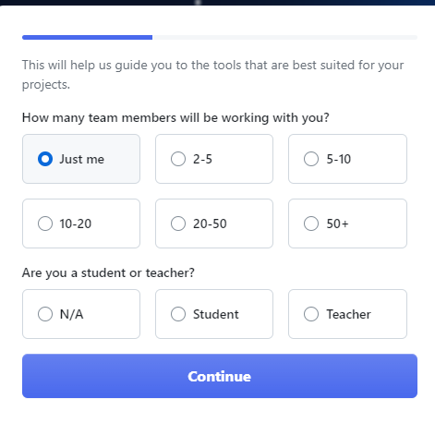

1. Click Continue>Next Widget

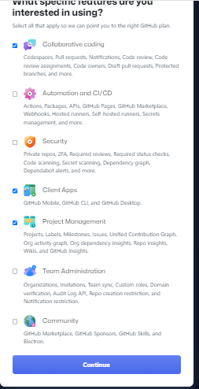

1. Click Continue>Next Step

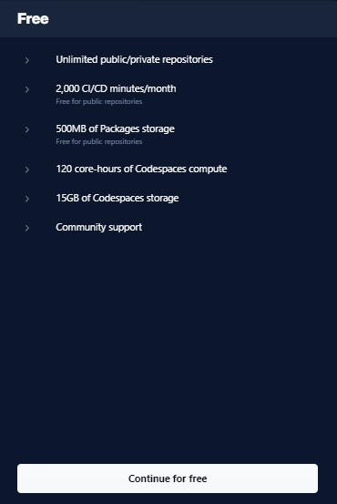

1. Continue for free
2. Dashboard

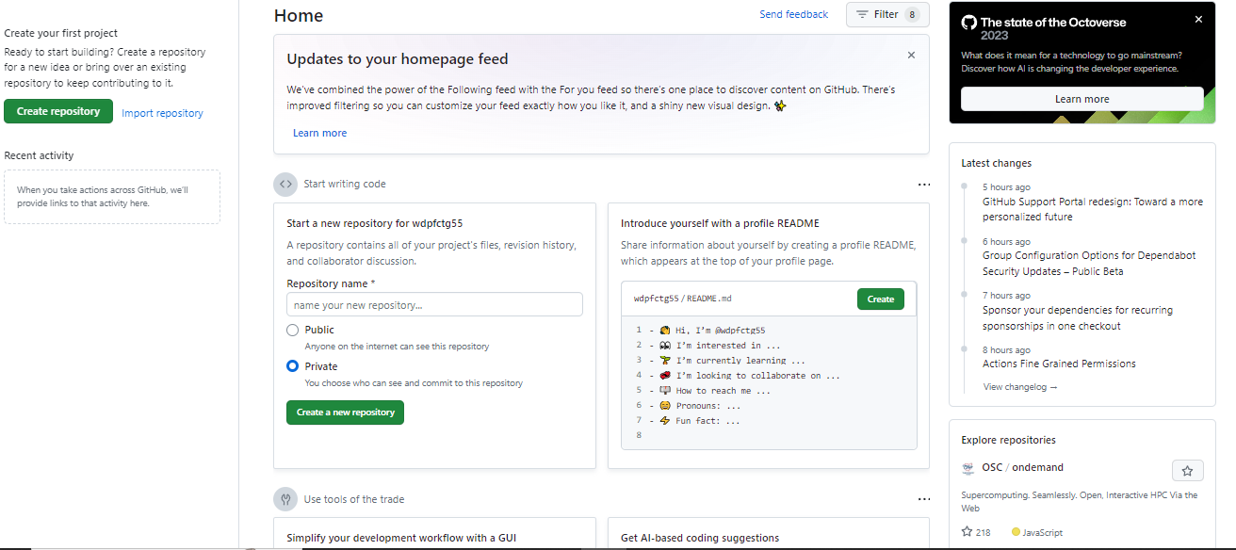

**File Repository in GitHub**

* 1. We shall create a github project on Repository Name: Starting Github>Public>Create a new Repository. Widget

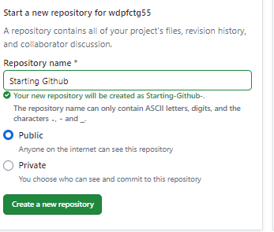

1. Click Create a new repository
2. Close all browser into
3. Enter into <https://github.com/>.
4. Dashboard Widget

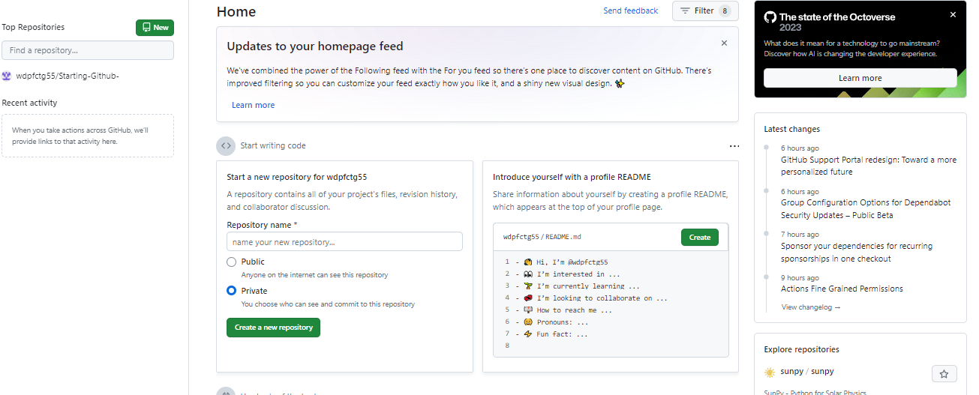

1. All your project repositories will be available into the left Panel.
2. Click your repository from left panel. Our repository name is starting-Github-
3. [https://github.com/wdpfctg55/**Starting-Github-**](https://github.com/wdpfctg55/Starting-Github-) will be shown if you click the repository
4. To create a new file click Add file>Creare a new file
5. To upload a file click Add file>Upload file as shown in the following widget

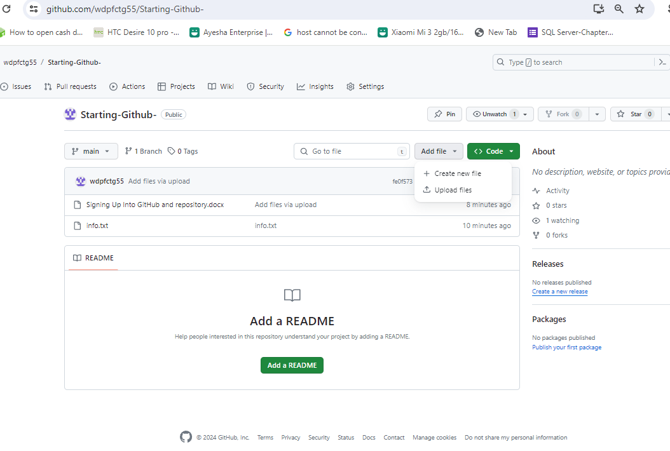

1. Our new created file was:

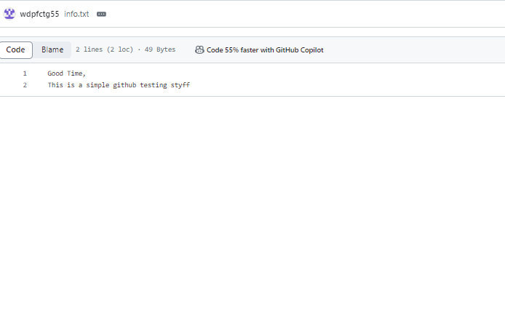

1. Our uploaded file was:

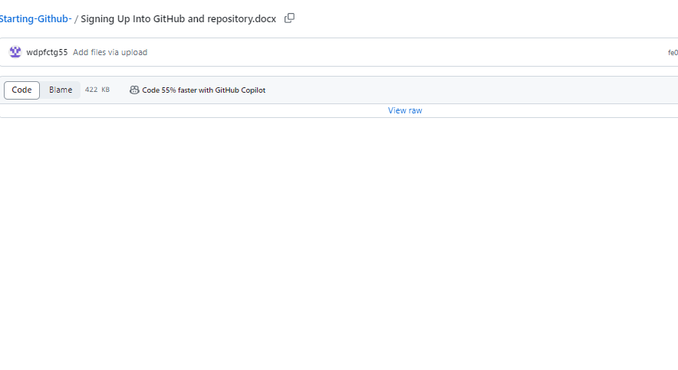

1. If you wish to change the repository name, go to settings